Software Documentation

1. Software Overview
The software reads sensor inputs in real time, processes the data, and controls motors and LEDs accordingly. It continuously monitors the ultrasonic sensor to detect hand position and translates that into motor movement direction and LED color changes. It also monitors the LDR for beam breaks and the push button for manual input, triggering the buzzer when needed.
MicroPython main programming language running on ESP32
Thonny IDE used to write and upload code to ESP32

2. System Logic
Ultrasonic → Motor flow:
- User moves hand above ultrasonic sensor
- Sensor fires pulse and measures distance in cm
- ESP32 smooths last 5 readings to remove noise
- Smoothed distance is mapped to a level between 0 and 10
- If level increased → motor 1 moves disk up
- If level decreased → motor 1 moves disk down
- Direction only changes after 1 second delay for smooth movement
- Motor 2 spins continuously throughout regardless of sensor
Laser → Buzzer flow:
- Laser beam hits 6 mirrors placed in a hexagonal shape and finally hits the LDR sensor
- ESP32 reads LDR value every loop cycle
- If value detected system is ready to go
- ESP32 triggers buzzer to sound
Button flow:
- User presses push button
- ESP32 detects signal change on button pin
- ESP32 triggers laser module to switch on
LED flow:
- ESP32 triggers LED to switch on after the LDR senses the Laser module.
- LEDs flicker and show colours inspired by the “Stranger things” atmospheric colours.

3. Flowchart
Ultrasonic Sensor Flow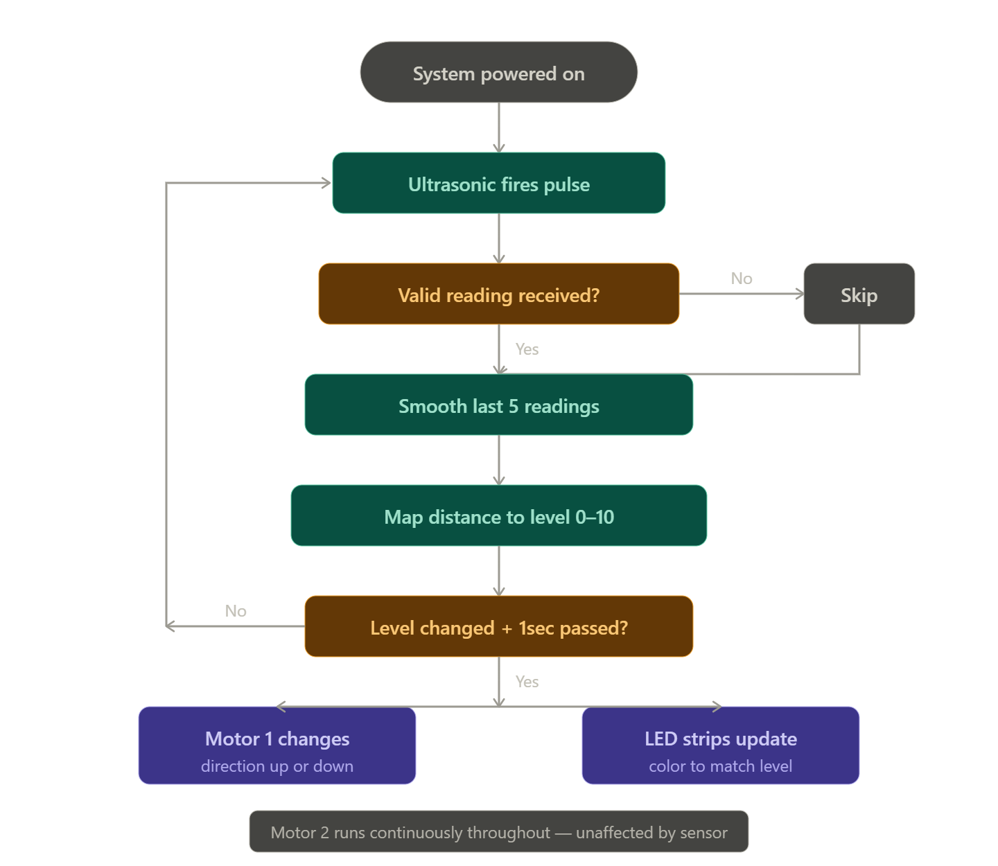
Laser + LDR Flow Neo Pixel + Motor Fl ow

